Creating a 15 Minute Presentation for the IEEE Holm Conference plus 5 minutes for Questions

Paul G. Slade

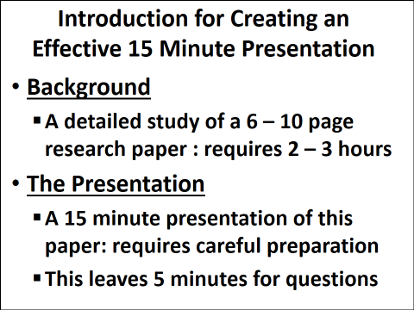
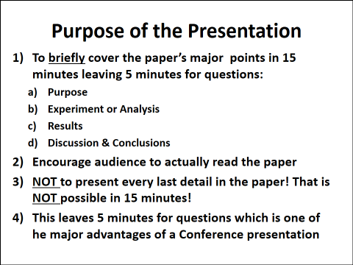

Designing a Technical Research Presentation for the IEEE Holm Conference:
An Example
From Jerry Witter
Title Page: 1 Slide
Title in clear large Fonts, Followed by Authors & Affiliation, Logo on this page only
Background (Purpose): 1 Slide recommended
List most important reasons for research compared to prior published work. No outline is needed for this short presentation.

Variables: 2 slides
Variables in DOE work are referred to as Factors. There are numerical factors and categorical factors. For items such as materials which are categorical it is good to abbreviate code names that can be associated with the factor rather than non-related codes to make it easier to understand the results. You will need one or two tables to define the variables. Make sure you list the important properties of each factor.

Testing Methods: 2 slides
Testing can be another variable but normally it will be a second experiment if more than one testing parameter is changed. Put the testing operation parameters in a table well labeled and with all the important parameters. A picture and or good description of the testing machine is another important input for understanding your work.

Results: 3 slides
Graphical results aid for interpreting results, trends and significance. Making you graph understandable is more important than jamming more information into a single graph. This takes good readable labeling of the axes and variable plots. Using double x axes is also distracting to the listener. It is better to make separate plots for different responses like contact resistance , erosion rate, and cycles life.

Discussion: 2 slides
Pick the most important issues, 3 or less, you want to clarify and combine them into no more than two slides. Quality is more important than volume. Use an illustration or picture if possible.

Conclusion: 1 slide
For results keep short statements,2nd to last: state more details in written paper and end with: Thank you for your attention.

The total is 12 slides including the title slide and this is the max.

General: Make it easy for your audience to understand your most important result and define your work in simple terms without non-defined acronyms, abbreviations, and specifications. Make the presentation easy for you and feel good about the result.

An Example of a 25 slide Presentation that lost the audience, because: (NOTE: this is a completely fictitious subject, authorship and presentation, but there have been attempted Presentations like this at the IEEE Holm Conference)
- Too many slides: 25
- Too much information on each slide: no time to read and to listen
- Too much detail: main points lost
- Too many slides that do not add, but detract from the presentation
- Impossible to present all of this in 15 minutes. There will be no time for questions. In fact the talk will go over the 20 minute allotted time: bad manners for the rest of the conference presenters.
- One major purpose of a Conference presentation is to have the question and answer session after each talk
This paper should have been considered a landmark paper on the “Womble” effect in electrical contacts. The paper itself gives new directions for experimental study of this effect and has very detailed experimental results and some interesting discussion and conclusions. A careful study of this paper would take at least 2-3 hours. It is impossible to present this paper in great detail during a 15 minute conference presentation. However, with the example that follows that is what the authors did attempt to do. As you will see there is so much information on most of the slides and they are difficult to read. There is enough information for a 60 minute talk! The audience would soon be overwhelmed and the significance of the paper would be lost. The authors should have arranged their talk to entice the audience’s attention and thus encourage them to read the paper later.
In the second example there is an illustration of how the authors could have arranged a 15 minute presentation which would have given those interested in the audience a general overview of their paper and interested them to read it later.
The original 25 Power-Point presentation as developed by the authors

Slide 1
- Good
- Some presenters like to place a logo. Just place it here on the title slide and nowhere else. Logos on every slide are a distraction
- This will be up for session chair’s introduction. Move immediately to slide 2
Slide 2 (1min 30sec)
- Unnecessary, eliminate
- It doesn’t say anything about the present research findings
- E-C researchers will be familiar with the “Womble” effect
Slide 3 (30sec) Total (2min)
- This seems to be conventional, but it takes up about 4% of the time allotted
- It can be eliminated
- Certainly eliminate the logo

Slide 4 (2min) Total (4min)
- Too much information, the audience while trying to read this will not really concentrate on what the speaker is telling them

Slide 5 (2min) Total (6min)
- Eliminate this slide, the experimental setups are discussed later in the presentation
- Wastes 2minutes of the total presentation time (13%)

Slide 6 (2min) Total (8min)
- Too much information plus 3 pictures
- 10 – 12 text lines maximum
- If adding a picture reduce the number of text lines
- Already used ½ presentation time
Slide 7 (30sec) Total (8min 30sec)
- Eliminate, there is no need to repeat this

Slide 8 (2min) Total (10min 30sec)
- Too much information on this slide
- Pictures are too small
- Limit to one larger picture and only up to 8 lines of text

Slide 9 (2min) Total (12min 30sec)
- Too much information on this slide, 11 text lines and 3 figures
- Pictures are too small
- The fonts too small on the figure labels too small and on the axes

Slide 10 (1min30sec) Total (14min)
- Too much information on this slide, 15 text lines and 3 pictures
- Pictures are too small

Slide 11 (2min) Total (16min)
- Too much information on this slide, 14 text lines and 2 pictures
- Pictures are too small
- All the Fonts too small

Slide 12 (3min) Total (17min)
- Too much information on this slide it would be difficult for the speaker to present this slide in 3 minutes
- Pictures and fonts are much too small
- This slide would be overwhelming for the audience.

Slide 13 (30sec) Total (17min30sec)
- Eliminate

Slide 14 (2min30sec) Total (20min)
- Too much information on this slide it would be difficult for the speaker to present this slide in 3 minutes
- Pictures and fonts are too small
- This slide would be overwhelming for the audience.
Slide 15 (3min) Total (23min)
- Too much information on this slide it would be difficult for the speaker to present this slide in 3 minutes
- Pictures and fonts are too small
- This slide would be overwhelming for the audience.
Slide 16 (1min) Total (24min)
- Too much information on this slide it would be difficult for the speaker to present this slide in 1minutes
- Pictures and fonts are too small

Slide 17 (3min) Total (27min)
- Too much information on this slide it would be difficult for the speaker to present this slide in 3 minutes
- Pictures and fonts are way too small
Slide 18 (30sec) Total (27min30sec)
- Eliminate

Slide 19 (1min30sec) Total (29min)
- 12 lines under the title is the maximum for the audience to read and also listen to the speaker
- A good example

Slide 20 (1min30sec) Total (29min)
- 12 lines under the title is the maximum for the audience to read and also listen to the speaker
- A good example

Slide 21 (1min30sec) Total (29min)
- 12 lines under the title is the maximum for the audience to read and also listen to the speaker
- A good example, but a maximum of 2 slides should have been used
Slide 22 (30sec) Total (29min30sec)
- Eliminate

Slide 23 (1min) Total (30min30sec)
- Eliminate: this slide is superfluous. Its message should have been stated in the “Discussion”

Slide 24(30sec) Total (31min)
- 9 lines under the title, a large font
- A excellent example of an audience friendly power point slide

Slide 25 Total (31min)
- NO COMMENT!!

An example of how the Power-Point Presentation could have been made in 11 slides (NOTE: this is not meant to be a template)

- The number of slides: 11
- About 1 minute 30 seconds for each slide
- Limited information on each slide: gives time to read and to listen to speaker
- Only essential main points on each slide
- Allows speaker time to elaborate main points
- There are no slides that detract from the main theme of the presentation
- Easy to presents in 15 minutes and allows time for questions: an essential part of a conference presentation
- It will keep the Conferences schedule of 20 minutes per speaker

- Good, large fonts
- Some presenters like to place a logo. Just place it here on the title slide and nowhere else. Logos on every slide are a distraction
- This will be up for session chair’s introduction. Move immediately to slide 1

Slide 1 (30sec) Total (30sec)
- This seems to be conventional, but it takes up about 4% of the time allotted
- It can be eliminated

Slide 2 (1min30sec) Total (2min)
- Only the major points on the slide
- Large font, easy to read and listen
- Allows the speaker to elaborate if needs be

Slide 3 (1min) Total (3min)
- Good, large fonts
- Easy to read and listen to the presenter at the same time
- Highlights the major purpose of the study
- Allows time for the presenter to elaborate some details

Slide 4 (1min) Total (4min)
- Good, large fonts
- Easy to read and listen to the presenter at the same time
- Highlights the major parameters for this study
- Allows time to elaborate if needed

Slide 5 (1min30sec) Total (5min30sec)
- One large picture or diagram of the apparatus with large font labels
- There will be time for the speaker to give more detail, if needed
- Only the major points on the slide
- Large font, easy to read and listen

Slide 6 (2min) Total (7min30sec)
- Good, large fonts
- Easy to read and listen to the presenter at the same time
- Highlights the major purpose of the study
- Allows time for the presenter to elaborate some details
- Only ½ allotted time spent

Slide 7 (1min30sec) Total (9min)
- One large picture or diagram of the apparatus with large font labels
- There will be time for the speaker to give more detail, if needed
- Only the major points on the slide
- Large font, easy to read and listen

Slide 8 (2min) Total (11min)
- Good, large fonts
- Easy to read and listen to the presenter at the same time
- Highlights the major purpose of the study
- Allows time for the presenter to elaborate some details
- Leave a good time for the Discussion of the data

Slide 9 (1min30sec)
Total (12min30sec)
- Good, large fonts, 10 lines
- Easy to read and listen to the presenter at the same time
- Highlights the major discussion points for this study
- Allows time for the presenter to elaborate some details

Slide 10 (1min30sec) Total (14min)
- Good, large fonts, 8 lines
- Easy to read and listen to the presenter at the same time
- Highlights the major discussion points for this study
- Allows time for the presenter to elaborate some details

Slide 11(1min) Total (15min)
- Good, large fonts, 9 lines
- Easy to read and listen to the presenter at the same time
- Highlights the major conclusions obtained from this study

